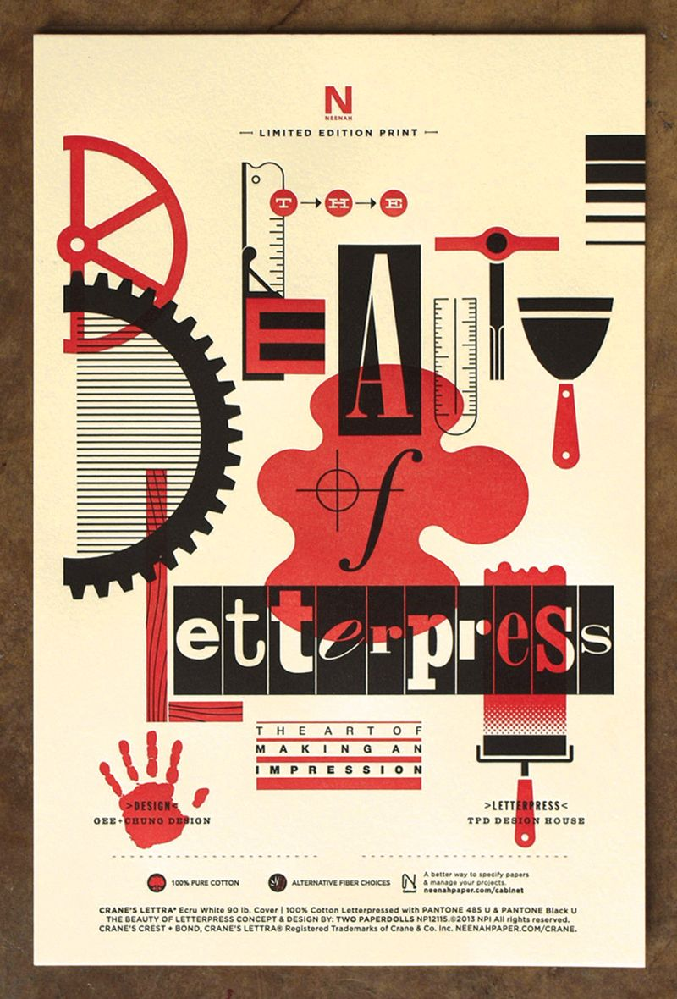

Neenah Paper Beauty of Letterpress Poster
10 Beautiful, Promo-Driven Poster Designs – PRINT Magazine
https://www.printmag.com/design-inspiration/10-beautiful-promo-driven-poster-designs/

